## DevOps Project - Jenkins CICD with GitHub Integration (ubuntu command)

Create AWS EC2 instance

sudo apt update

3 sudo apt install openjdk-11-jre

4 java -version

5 curl -fsSL https://pkg.jenkins.io/debian/jenkins.io.key | sudo tee \ /usr/share/keyrings/jenkins-keyring.asc > /dev/null

6 echo deb [signed-by=/usr/share/keyrings/jenkins-keyring.asc] \ https://pkg.jenkins.io/debian binary/ | sudo tee \ /etc/apt/sources.list.d/jenkins.list > /dev/null

7 sudo apt-get update

8 sudo apt-get install jenkins

9 sudo systemctl enable jenkins

10 sudo systemctl start jenkins

11 sudo systemctl status jenkins

12 sudo cat /var/lib/jenkins/secrets/initialAdminPassword

13 history

ssh-keygen

ssh-keygen

2 cd .ssh

By using above command I will get o/p “authorized_keys id_rsa id_rsa.pub”

4 cat id_rsa (Private Key)

5 cat id_rsa.pub (Public Key)

Now go in Github and in setting click on SSH and GPG keys, while creating it will asks SSH public key which is generated by using ssh-keygen command in linux.Then addig to the SSH key it will ask for authentication token if I used two factor authenticator.Now, github have public access to connect to ec2 instance.

In jenkins I have to go in Source code management and have to configure git by giving private key credentials by adding it and saving it will only “Integrate Github with Jenkins”.

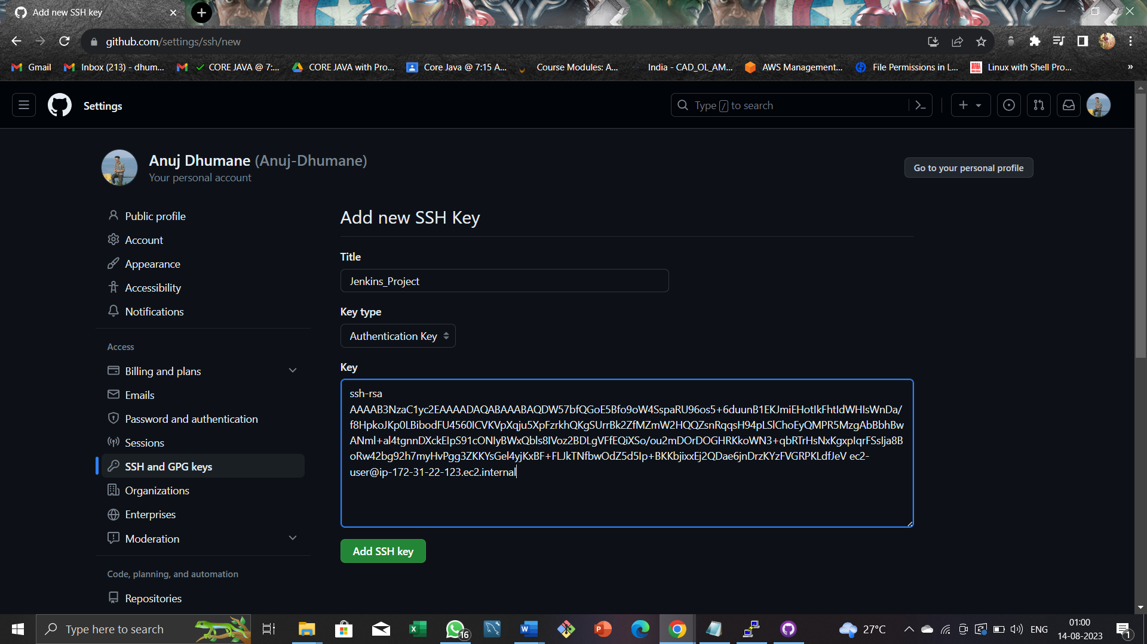

Then by clicking on “Build now” option from left side it will start pipeline.

A Jenkins build job contains the configuration for automating a specific task or step in the application building process. These tasks include gathering dependencies, compiling, archiving, or transforming code, and testing and deploying code in different environments.

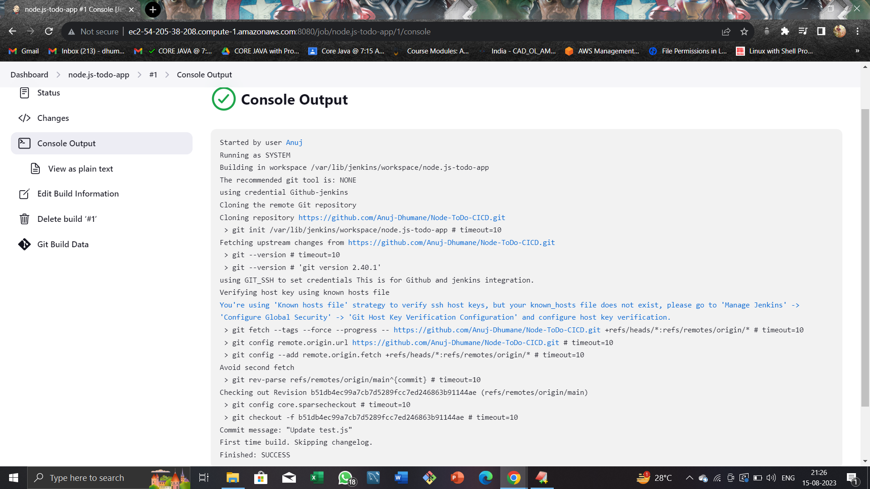Then it will output like which is shown in below image.

Means its showing successfully integrated.

Now in my server machine I installed nodejs and node package manager (npm)

Step 2: Install Node.js

NPM is included with Node.js, so you need to install Node.js first. To install Node.js, run the following command:

sudo yum install nodejs

Step 3: Verify Node.js Installation

After installing Node.js, verify the installation by running the following command:

node -v

This command should output the version number of Node.js. If not, there may have been an error during the installation process.

Step 4: Install NPM

Now that Node.js is installed, you can install NPM using the following command:

sudo yum install npm

Step 5: Verify NPM Installation

After installing NPM, verify the installation by running the following command:

npm -v

This command should output the version number of NPM. If not, there may have been an error during the installation process.

sudo apt install docker.io

FROM node:12.2.0-alpine

WORKDIR app

COPY . .

RUN npm install

EXPOSE 8000

CMD ["node","app.js"]

docker build . -t node-app

sudo usermod -a -G docker $USER

docker run -d --name node-todo-app -p 8000:8000 todo-node-app

Got to jenkins job

Execute shell

docker build . -t node-app-todo

docker run -d --name node-app-container -p 8000:8000 node-app-todo